Inference :

Dependent variable : Attrition

Independent variable : Monthly total income , Age and Total Working years .

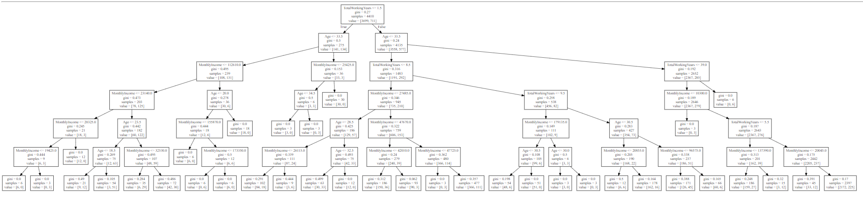

-> 3 people whose monthly income is between 19425 and 20325 and total working hours is below 1.5 years have left the company .

-> 51 people who are below 23.5 of age and monthly income is below 23140 have left the company.

-> 6 people who below age of 20 and have monthly income below 173350 have left the company.

-> 18 people who are below 28.5 age and have monthly income below 26115 have left the company.

-> 3 people who between 33.5 and 34.5 in age and have monthly income below 25425 have left the company.

-> 33 people below 32.5 in age and have monthly income below 27485 have left the company.

-> 36 people below the age 33.5 and monthly income below 42010 have left company.

-> 111 people whose age is below 33.5 and income between 27485 and 47725 have left the company.

-> 3 people with total working years below 9.5 years and age above 30 have left the company.

-> 6 people below 30.5 in age and monthly income below 179135 and total working years below 9.5 have left the company.

-> 27 people who have monthly income below 137390 and total working years is below 5.5 years have left company

-> 12 people who have monthly income lesser than 20045 and total working years between 5.5 and 39 .

-> 225 people who have monthly between 10300 and 20045 and total working between 5.5 and 39.